DBS LAB # 03
24K-2054
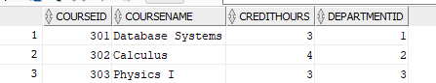
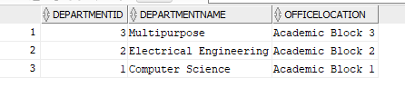
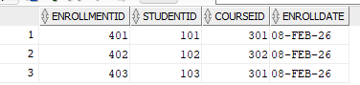
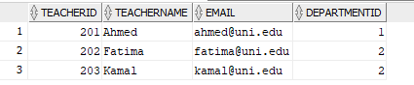
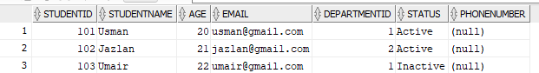
Database Created:

- Primary Keys
- Departments → DepartmentID
- Students → StudentID
- Teachers → TeacherID
- Courses → CourseID
- Enrollments → EnrollmentID
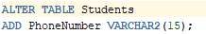
- Write an SQL command to add PhoneNumber column in Students table.

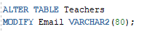
3. Modify the Email column size in Teachers table to 80 characters.

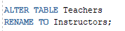
- Rename table Teachers to Instructors.

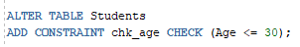
- Add a CHECK constraint to ensure Age ≤ 30.

- Insert a new student who belongs to Computer Science department.

- Try inserting a student with Age = 15. What happens and why?

The student gets entered as it satisfies the condition of age <= 30
- Add a UNIQUE constraint on CourseName.
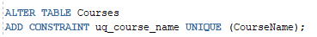
- Write SQL to insert a course without specifying CreditHours.
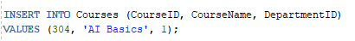

- Add a FOREIGN KEY in Enrollments using ALTER TABLE
